User Guide

for

Make A Topographic Map (MATM)

Provincial Mapping

Mapping and Information Resources Branch

Corporate Management and Information Division

Ministry of Natural Resources and Forestry

2023-05-08

Disclaimer

This technical documentation has been prepared by His Majesty the King in right of Ontario as represented by the Ministry of Natural Resources and Forestry (the “Ministry”). No warranties or representations, express or implied, statutory, or otherwise shall apply or are being made by the Ministry with respect to the documentation, its accuracy or its completeness. In no event will the Ministry be liable or responsible for any lost profits, loss of revenue or earnings, claims by third parties or for any economic, indirect, special, incidental, consequential or exemplary damage resulting from any errors, inaccuracies or omissions in this documentation; and in no event will the Ministry’s liability for any such errors, inaccuracies or omissions on any particular claim, proceeding or action, exceed the actual consideration paid by the claimant involved to the Ministry for the materials to which this instructional documentation relates. Save and except for the liability expressly provided for above, the Ministry shall have no obligation, duty or liability whatsoever in contract, tort or otherwise, including any liability or negligence. The limitations, exclusions and disclaimers expressed above shall apply irrespective of the nature of any cause of action, demand or action, including but not limited to breach of contract, negligence, strict liability, tort or any other legal theory, and shall survive any fundamental breach or breaches.

Additional Information

For more information about this document, please contact Provincial Mapping at [pmu@ontario.ca](mailto:pmu@ontario.ca)

Table of Contents

Disclaimer 2

Additional Information 2

Table of Contents 3

1. Overview 4

2. Application-Level Controls 5

2.1 Map Controls and Options 5

2.2 The “I Want To…” control 7

3. Tab Controls 9

3.1 About Tab 10

3.2 Navigation Tab 10

3.3 Map Layers Tab 12

3.4 Search Tab 13

3.5 Measure Tab 18

3.6 Markup & Printing Tab 21

3.6.1 Descriptions of markup tools available under the Markup & Printing tab: 21

3.6.2 Printing from the Markup & Printing tab: 23

4. Feedback 26

Appendix A: LIO Topographic Data Cache Legend 27

Appendix B: Frequently Asked Questions 29

Appendix C: Accessibility features 32

Appendix D: Customization with Markup Styles 36

Appendix E: Sample MATM Output Map 40

1. Overview

Make a Topographic Map (MATM) shows topographic information, such as roads, trails, lakes, rivers, wooded areas, wetlands and provincial parks, as well as municipal and township boundaries. Users can zoom in and out, find places and turn satellite imagery on or off. Create a custom map of any part of Ontario, add text or polygons and print or download a copy. This document provides help for users of MATM, including information on how to find addresses, measure distances, create customized markup and print maps.

Note: MATM is optimized to run in current versions of Google Chrome, Chrome on Android, Mozilla Firefox, Microsoft Edge, Safari on iOS 11+ or Internet Explorer 11.0+. Users with earlier web browsers may experience decreased functionality in the application.

[Launch Make a Topographic Map](https://www.lioapplications.lrc.gov.on.ca/MakeATopographicMap/index.html?viewer=Make_A_Topographic_Map.MATM&locale=en-CA)

2. Application-Level Controls

2.1 Map Controls and Options

These are controls available on the application map surround that allow the user to interact with the map or provide shortcuts to display options and useful tools.

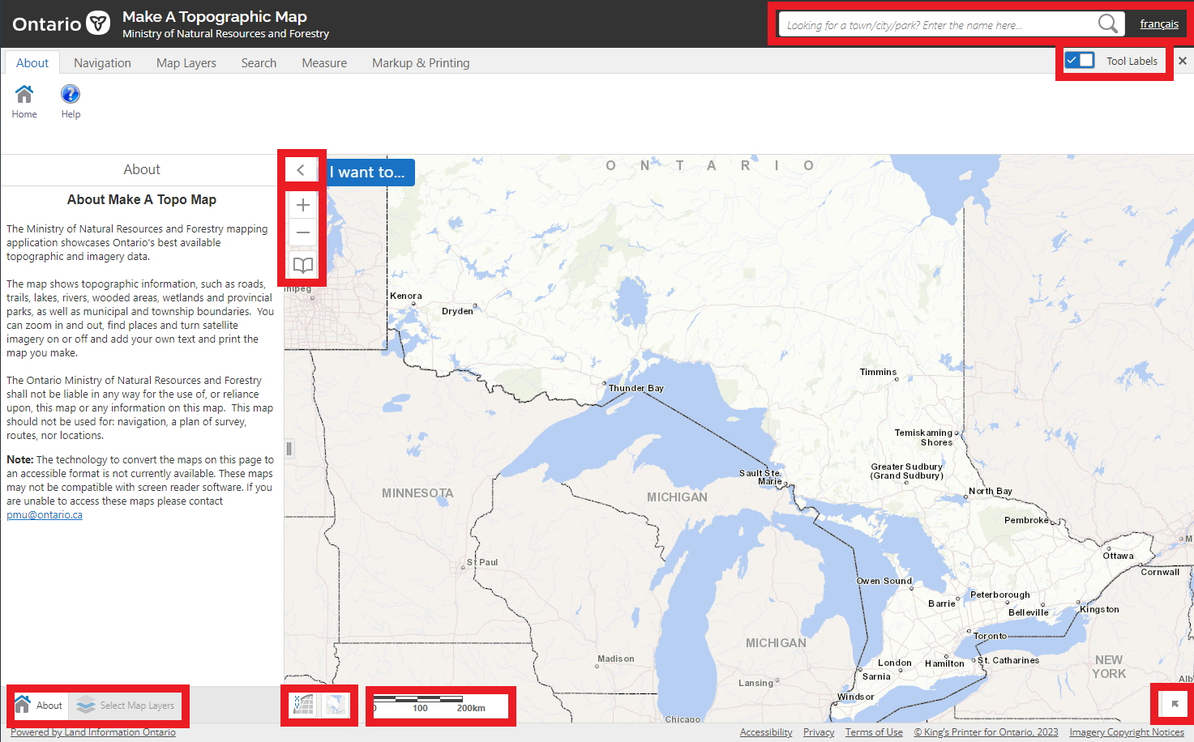

Location of application-level controls.

**2.1.1 Description of controls and options available from the map screen:**

|  |  |
| --- | --- |
| **Control Image** | **Control Description** |
| <keyboard shortcut> | **Full Screen:** Application switches to full screen mode using **F11** on the keyboard. Use the key again and return all tabs and browser elements to their normal state. |
| <right click>Example of the geocoding results for a selected location on the map. | **Geocode Location / Plot Coordinates:** Right-click on the map to get the coordinate location in degrees, minutes, seconds or decimal degrees and street address (if available).   * Click **Plot a Coordinate** to insert a label onto the map.   Map coordinate label drawn on selected location on the map. |
| Français button icon. | **Language:** Switch from French to English or English to French. |
| Example of quick search text box. | **Search:** A quick search option. Type the name of a town or other location and select Search. Search Results opens and displays any matching results. |
| Open Toolbar button icon. | **Open Toolbar:** Hides the toolbar tabs when selected once. Select again and it restores the toolbar. |
| Overview Map button icon. | **Overview Map:** Open by selecting the arrow at the bottom right of the map view. Select and drag the blue box and the view will also move.  Overview map example. |
| Sample scalebar. | **Scale:** Scale bar adjusts with the map view. |
| Coordinate Widget example.  Shows Lat/Long coordinate type option with the current coordinates. | **Coordinate Widget**: Select to open the Coordinate Widget. Select between lat. or long. and degrees, minutes or seconds to view the coordinates at the cursor position. |
| Bookmarks button icon. | **Bookmarks:** Opens the Bookmarked Locations window, described in Navigation. |
| Zoom in and Zoom out icon.  Zoom in is represented with a "+" symbol (top) and Zoom out with a "-" symbol (bottom). | **Zoom In / Zoom Out:** Zoom in and out using the plus or minus buttons. |
| "Find Me" button icon. | **Find Me:** Zooms once to GPS location on the map. (GPS enabled phone or tablet) |
| `"Follow Me" button icon. | **Follow Me:** Continuously re-centers map with current location. (GPS enabled phone or tablet) |

2.2 The “I Want To…” control

The **“I want to…”** control provides quick access to multiple other tools.

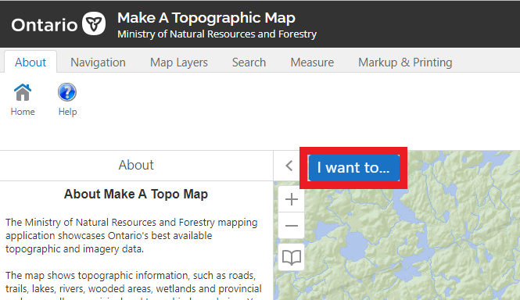

Location of the "I want to..." control.

**2.2.1 The following tools can be accessed from the “I want to…” control.**

|  |  |
| --- | --- |
| **Control Image** | **Control Description** |
| Find an address too.  Find an address using a geocoding service. | **Find an address:** Refer to “Navigation” for further information on searching by location. |
| I want to... control "Area" button icon.  Text reads: Calculate area for a defined shape" | **Area:** Refer to “Measure” for further information on measuring area. |
| I want to... control "Distance" button icon.  Text reads: "Draw a multi-part line to measure a distance" | **Distance:** Refer to “Measure” for further information on measuring distances. |
| I want to... control "Print" button icon.  Text reads: "Create a printable version of the map". | **Printing:** Refer to “Markup and Printing” for further information on how to create and print a custom map. |
| I want to... control "Change visible map layers" button icon.  Text reads: "Alter visibility of map layers, perform layer actions, and view the legend." | **Change visible map layers:** Refer to “Map Layers” for further information on how to turn map layers on and off. |
| I want to... control "Bookmark current map extent" button icon.  Text reads: "Add the current map extent to the list of bookmarks, so that I can return to it later." | **Bookmark current map extent:** Type a name and select OK to save a bookmark of the current location in the map view. |
| I want to... control "Return to initial map extent" button icon.  Text reads: "Return to the initial map position and zoom level". | **Return to initial map extent:** Select to zoom out to the full province view. |
| I want to... control "See What's New" button icon.  Text reads: "See what has been updated in this release" | **See What’s New**: Click to see a list of the most recent updates to MATM. |

3. Tab Controls

The Tab Control provides access to several tools grouped by function.

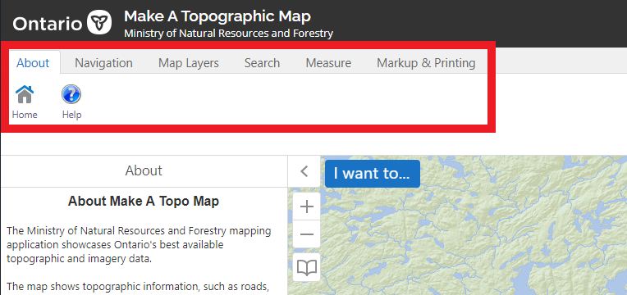

Location of the Tab controls.

3.1 About Tab

The **About tab** provides information about the MATM application

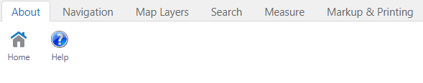

**3.1.1 Description of tools available under the About tab:**

|  |  |
| --- | --- |
| **Control Image** | **Control Description** |
| "Home" button icon. | **Home:** Select the **Home** button for relevant information about the application tool. |
| "Help" button icon. | **Help:** Select **Help** to access this User Guide for details on how to use the MATM Application |

3.2 Navigation Tab

The Navigation tab provides tools for saving map locations, moving about the map and changing the map scale/extent.

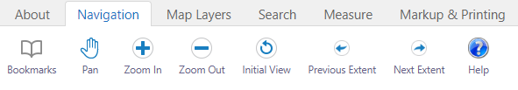

**3.2.1 Descriptions of tools available under the Navigation tab:**

|  |  |
| --- | --- |
| **Control Image** | **Control Description** |
| "Bookmarks" button icon. | **Bookmarks:** The Bookmarks tool allows the user to add new locations and store them in a list. The window opens into the map view, with a default bookmarked location for the Provincial extent already set. |
| "Bookmarked Locations" dropdown control listing two sample bookmarked locations and a "Bookmark Current Extent" control. | **Bookmark Current Extent**   * Zoom to a desired location * Select the Bookmarks button, then type a name for the location. * Select OK or select Enter. * The location is added to the bookmarks list. The X to the left of the bookmark will remove it. |
| "Pan" button icon. | **Pan:** Moves the map view around. Select and drag the map or use direction keys on the keyboard to move the viewable area. |
| "Zoom In / Zoom Out" control icon. | **Zoom In / Zoom Out:** Select the tool and draw a box around an area of interest to zoom in / out or use the scroll wheel. Double selecting while in Pan or Zoom modes also zooms in. |
| "Initial View" button icon. | **Initial View:** Returns to the full Province view. |
| "Previous Extent / Next Extent" control icon. | **Previous Extent and Next Extent:** Returns to the previous view. Next Extent will be greyed out until the user has selected Previous Extent. Select to step through past views. |

3.3 Map Layers Tab

The **Map Layers** tab provides access to controls for displaying map layers and the legend.

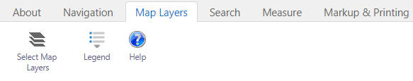

**3.3.1 Descriptions of tools available under the Map Layers tab:**

|  |  |
| --- | --- |
| **Control Image** | **Control Description** |
| "Select Map Layers" button icon. | **Select Map Layers:** Used for turning map layers on and off. |
| "Select Map Layers" window listing Assessment Parcel, Topographic and Imagery layers. | * Select the checkbox beside a layer to make visible * Unselect the checkbox to hide a layer * Adjust the slider to control transparency. |
| "Legend" button icon. | **Legend:** Opens the legend to the topographic map features. |

3.4 Search Tab

The **Search** tab includes eight tools for finding a location (described below). Select an item from the list and select Search to launch the tool. Once opened each tool also provides some direction for use.

Note: The Assessment Parcel feature search will only be available if the Ontario Parcel Licence Agreement was accepted when starting the application.

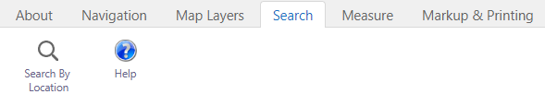

**3.4.1 Descriptions of tools available under the Search tab:**

|  |  |
| --- | --- |
| **Control Image** | **Control Description** |
| "Search By Location" button icon. | **Search By Location** opens the list of search tools listed below. |
|  |  |
| Find an Address or Place button icon.  Search by address, intersection, or place name. | **Find an Address**  Allows users to locate an address.   * Enter an address with or without a street number. * Enter a municipality (optional). * Select Search.A list of potential matches appears in a results panel. The list can be switched to table format, and an option to clear the selected features is also available. * Users can toggle through the list to select the most suitable location. |
| Find a Municipality or District button icon. Search for a specific municipality or  district. | **Municipality or District**  Search for Municipalities or districts by name.   * Enter at least the first few characters of the Municipality name. * From the list, select the desired municipality and select Search. * A red box will highlight the area of interest in the map view. * Select Clear to remove the red box. |
| Select a Township & Lot/Concession button icon.  Search for a geographic township & lot/concession. | **Township/Lot/Concession**  Search on Geographic Township with or without Lot and Concession details. A Township is required for the search to proceed.  **Search for Township alone:**   * Enter at least the first few characters of the Township. * From the list, select the desired Township and select Search. * A red box will highlight the area of interest in the map view. * Select Clear to remove the red box.   **With Lot and Concession:**   * Type a Township into the Township field, or at least the first few characters of the name. * From the list, select the desired Township. * Add in Lot and Concession. Add Direction if necessary. * Select Search. The map view zooms to the chosen Lot and Concession, highlighted with a red box. |
| Find an Assessment Parcel button icon. Search for a parcel by assessment roll number. | **Find an Assessment Parcel**  Search for a parcel by Assessment Roll Number (ARN)   * Enter the exact 15-digit or 20-digit ARN. * Select Search * A red box will highlight the area of interest in the map view. * Select Clear to remove the red box. |
|  |  |
| Find a Place by Geographic Name button icon. Search the official Geographic Names of Ontario. | **Find a Place by Geographic Name**  Search for a named place and filter by feature type.   * Enter the name, or one or more words that form the name. * Optionally select the type of feature the name applies to. * Select Search * Pick the feature from the list of potential matches. |
| Find a Trail button icon. Search for a trail by name.  Find a Road button icon. Search for a road by name.  Find an Airport button icon.  Search for an airport by name. | **Find Trails, Roads, or Airports**  Search by data layer to identify a list of features and zoom.   * From Search By Location, choose data layer and select Search. * Type the name of the feature. * Select the Search button. Results appear in the panel which can be switched between table or list view. * Users can toggle through the list to select the most suitable location. |
|  |  |
| Go to Latitude/Longitude (DD) button icon. Zoom to coordinate (decimal degrees)  Go to Latitude/Longitude (DMS) button icon. Zoom to coordinate (degrees, minutes, seconds)  Go to UTM Coordinate button icon. Zoom to coordinate (zone, easting, northing) | **Search by coordinates**   * Search for a location choosing from one of three coordinate systems. * Select the coordinate system of your choice. * Enter the coordinates in the textboxes using the format as show by the sample text. * Select Search to zoom to the indicated location. |

3.5 Measure Tab

The Measure tools let users measure distance or area on the map using a choice of shapes and units of measure.

Note: Users can change the unit of measure at any time, but all areas and / or distances measured will change accordingly.

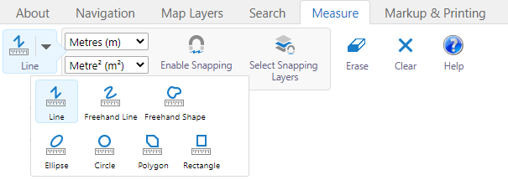

**3.5.1 Descriptions of tools available under the Measure tab:**

|  |  |
| --- | --- |
| **Control Image** | **Control Description** |
| Units of measures control.  The top control is a dropdown list for linear units.  The bottom control is a dropdown list for area units. | **Units of Measure**  Units of Measure should be set prior to using measurement tools  Select the desired linear units of measurement (Feet, Yards, Metres, Kilometres, Miles, or Nautical Miles) |
| "Freehand Line" button icon. | **Freehand Line**   * Select a starting location on the map and trace a path. |
| "Line" button icon. | **Line**   * Select a starting location and click each additional waypoint. * Double-select to finish the line. |
| "Freehand Shape" button icon. | **Freehand Shape**   * Select a start location and trace the outline of the area to be enclosed by the shape. |
| "Ellipse" and "Circle" button icons. | **Ellipse or circle**   * Select a centre-point and drag the shape to the desired size. |
| "Rectangle" button icon. | **Rectangle**   * Select a corner starting point and drag the rectangle to the desired size in any direction. |
| "Polygon" button icon. | **Polygon**   * Select a starting point and continue to select locations around the perimeter of the desired area and double select to complete the shape. |
| "Enable Snapping" button icon. | **Snapping**   * Click Enable Snapping to assist with connecting or aligning you markup sketches with edges or endpoints of other sketches or selected snapping layers.   Note: only the Assessment Parcel layer is currently available for snapping (default). |

3.6 Markup & Printing Tab

The Markup and Printing tab provides drawing and text options as well as the ability to create a map document file for export and printing.

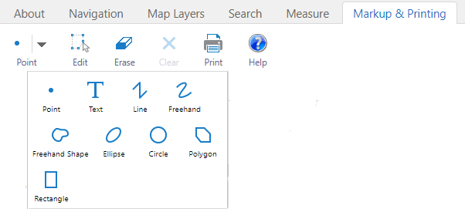

3.6.1 Descriptions of markup tools available under the Markup & Printing tab:

|  |  |
| --- | --- |
| **Control Image** | **Control Description** |
| "Point" button icon. | **Point:** add point(s). |
| "Text" button icon. | **Text:** add text. |
| "Line" button icon. | **Line:** add line(s). Double-select to end the line. |
| "Freehand" button icon. | **Freehand:** add free form line(s). Double-select to finish the line. |
| "Freehand Shape" button icon. | **Freehand Shape:** add free form polygon(s) of desired size or shape. |
| "Ellipse" button icon. | **Ellipse:** add ellipse(s) of desired size or shape. |
| "Circle" button icon. | **Circle:** add circle(s) of desired size. |
| "Polygon" button icon. | **Polygon:** add polygon(s) of desired size or shape. Double-select to finish the polygon. |
| "Rectangle" button icon. | **Rectangle:** add rectangle(s) of desired size or shape. Double-select to finish the rectangle. |
| "Edit" button icon. | **Edit:** to modify the shape of a markup feature, select Edit, then select the desired markup feature and edit as desired. |
| "Erase" button icon. | **Erase:** Permanently erase any markup by selecting an existing drawing. |
| "Clear" button icon. | **Clear:** Permanently erase all drawings added. A pop-up will appear to confirm all drawings will be deleted. Choose **OK** to proceed or **Cancel** to preserve drawings. Drawings cannot be exported and saved. |
| "Styles" button icon. | **Styles:** This versatile control only appears in the Markup & Printing toolbar once Markup is added to the map.  Click the Styles button to open a context-sensitive menu that provides style options dependent on the type of markup currently selected.  Refer to Appendix D for more information about creating customized markup styles. |
| "Enable Snapping" button icon. | **Snapping:** Enable Snapping & Select Snapping Layers controls only appear once markup is added to the map.   * Click Enable Snapping to assist with connecting or aligning you markup sketches with edges or endpoints of other sketches or selected snapping layers.   Note: Only the Assessment Parcel layer is currently available for snapping (default). |

3.6.2 Printing from the Markup & Printing tab:

|  |  |
| --- | --- |
| **Control Image** | **Control Description** |
| "Print" button icon. | **Print:** Opens the Print Map Form allowing you to set the options for producing a map from MATM. |
| "Select Layout" graphic user interface listing page size options. | **Select Layout** to set the output map size. |
| "Resolution" graphic user interface showing standard (96 dpi). | **Resolution:** 96 dpi is the only print resolution currently available. |
| "Map Scale" graphic user interface listing available scale options. | **Map Scale:** Select the scale of the map to be printed from the list of available options.  Current Scale is the same as current extent, unless the map zoom is changed with Lock preview with map enabled.  Current Extent is the scale of the current map extent.  The listed fixed scales match the scale levels of the underlying topographic map cache for optimal display properties. |
| "Title" and "Notes" text box. | **Title & Notes:** The text you enter here will appear in the upper right-hand corner of the map surround. |
| "Lock print preview with map" checkbox. | **Lock print preview** fixes the print extent to the current location and scale.  Note: Setting the map scale to “Current Extent” overrides this function, while changing the selected scale or layout page size will change the size of the print area indicated by red shaded rectangle.  Screen capture of map showing print preview shaded rectangle. |
| "Print" and "Cancel" button icons.  Message: "Your file is ready. To view the file please click Open File".   "Open File" button icon. | **Print:** Generates a map file from the specified settings and extents and includes a map surround including the legend, scale, index map, scale and metadata including copyright information and disclaimers.  **Open File** is available when file generation is complete. Select to see the resulting map file which can be printed to hardcopy or saved on your device. Refer to Appendix E: Sample MATM Output Map. |

4. Feedback

Please email a screen capture of the missing data or error to [pmu@ontario.ca](mailto:pmu@ontario.ca). Submissions will be reviewed and considered where appropriate.

Appendix A: LIO Topographic Data Cache Legend

LIO Topographic Data Cache Legend

First half of the English legend for the LIO Topographic Data Cache.

LIO Topographic Data Cache Legend

Second half of the English legend for the LIO Topographic Data Cache.

Appendix B: Frequently Asked Questions

**Where does the information in this map come from?**

The MATM shows the following data:

|  |  |
| --- | --- |
| * Administrative Boundaries – Provincial boundaries, municipalities, townships, lots and concessions, assessment parcel, provincial parks, conservation reserves, national parks, Indian reserves and other federal lands * Airports * Bridges and Tunnels * Buildings * Dams * Elevation - Contours * Elevation - spot heights | * Falls, Rapids and Rocks * Lakes and Rivers * Place Names * Pipelines * Railways * Roads * Imagery * Trails * Transmission Lines * Wetlands * Wooded Areas |

**How was this web map created?**

The map uses a topographic data cache to display data. A cache is a series of pre-drawn maps that are selected for fast, seamless display at predefined scales in web maps. The cache is a snapshot of the various data layers.

To find out more about the LIO Topographic Data Cache, please view the [Ontario GeoHub page](https://geohub.lio.gov.on.ca/datasets/mnrf::lio-topographic-data-cache/about).

**How current is the data?**

Each of the data layers has different maintenance cycles and is updated at different times.

To find out more about the data’s currency, please view the [LIO Topographic Data Cache Ontario GeoHub page](https://geohub.lio.gov.on.ca/datasets/mnrf::lio-topographic-data-cache/about).

**Why are some buildings missing from the map?**

The Ministry of Natural Resources and Forestry (MNRF) no longer maintains building data across the province. Look at the Ontario imagery under the Map Layers tab to see more buildings.

**Where do the names of lakes, rivers, islands, cities and other features come from?**

This map features the official names approved by the [Ontario Geographic Names Board.](https://www.ontario.ca/page/geographic-names) You may see alternate names appear in brackets for some places and geographic features.

**Can I download data from this map?**

Data cannot be downloaded directly from this web map. However, most data layers can be downloaded from the [Ontario GeoHub.](https://geohub.lio.gov.on.ca/)

**Can I save and print my map?**

Select the Markup and Printing tab to save and print the map you make. There are also tools that let you customize your map. Refer to “Markup and Printing” for further information on how to create a map.

**How do I report an error or missing data?**

We want your feedback. Please email a screen capture of the missing data or error to [pmu@ontario.ca](mailto:pmu@ontario.ca). Submissions will be reviewed and considered where appropriate.

**Why is there white space in the map?**

When you zoom in beyond each map layer’s limit it may disappear (leaving white space in the map view) due to a variety of factors:

* LIO Topographic Data Cache has accuracy restrictions limiting how far you can zoom in
* Ontario Imagery resolution varies across the province
* Assessment parcel data does not exist for all of Ontario

**What browsers are supported by MATM?**

* Google Chrome (current version recommended)
* Mozilla Firefox (current version recommended)
* Microsoft Edge (current version recommended)
* Microsoft Internet Explorer 11.0 and greater
* Safari on iOS 11+ (Safari on iOS 14 recommended)
* Chrome on Android (current version recommended)

Appendix C: Accessibility features

MATM uses the VertiGIS Studio Geocortex Viewer HTML5 4.14 which adheres to Web Content Accessibility Guidelines (WCAG) 2.0. There are two aspects to accessibility support in MATM:

**1. Screen Readers**

Screen readers read the application text aloud, so the user can listen to the page instead of seeing it. The text is read aloud where the mouse pointer is positioned. The application can be navigated by using a mouse, the keyboard, a sip-and-puff device or any other type of navigation device. There are three pieces of information that are provided about the map:

* The coordinates at the centre of the current map extent.
* The current scale of the map. The scale is only provided when the zoom level changes.
* The number of visible features of each visible layer.

To make the screen reader read out information about the map without changing the map extent, select the map with either the mouse or the TAB key.

**2. Keyboard Shortcuts**

Keyboard shortcuts allow interaction with MATM using a keyboard instead of a mouse. The active command is highlighted with a red border. Keyboard shortcuts provide a level of precision that a mouse does not. You can move or resize a shape by a single pixel using the keyboard. At this time, Freehand Draw and Multi-point Identify Operations cannot be controlled using the keyboard.

**HTML5 standard keyboard shortcuts to navigate the page and select or activate items:**

**TAB:** Navigate forward through the page’s components.

**SHIFT + TAB:** Navigate backward through the page’s components

**ENTER:** Select or activate the current user interface component

**SPACE BAR:** Select checkbox

**Arrow keys:** Pan the map (if selected), or move slider

**PAGE UP; PAGE DOWN:** Jump slider

**HOME; END:** Jump slider to the start or end

**HTML5 MATM Application Keyboard Shortcuts**

The application uses shortcuts for working with shapes, including text markup. These shortcuts are used with tools that require the user to manipulate a shape on the map, specifically, identify, draw, measure and edit tools. For greater precision when moving, rotating, or resizing a shape, hold down the ALT key while selecting the desired shortcut keys. For example, Select ALT + LEFT ARROW to move the selected shape one pixel to the left.

**ENTER/EXIT:** add a vertex to the shape that you are creating, or exit vertex editing mode

**Arrow keys:** moves a vertex or shape horizontally or vertically

**PAGE UP; PAGE DOWN; HOME; END keys:** Move the selected shape or vertex diagonally

**S:** enlarge the selected shape uniformly

**SHIFT + S:** reduce the selected shape uniformly

**R:** rotate the selected shape to the right

**SHIFT + R:** rotate the selected shape to the left

**ENTER, ENTER:** Select enter twice to complete the shape

**V:** Enter vertex editing mode or select the next vertex of the current shape (in vertex editing mode)

**SHIFT + V:** select the previous vertex of the current shape (in vertex editing mode)

**D:** Delete vertex

**Use the Keyboard to Measure Distance**

* Select TAB as many times as needed to navigate to the Measure tool.
* Select ENTER to open the Measure tool. The pointer is positioned on the Measure Distance tool.
* Select ENTER to activate the Measure Distance tool.
* Select ENTER to create the first vertex. Because you are drawing a line, the vertex is an endpoint.
* Use the arrow keys and diagonal movement keys to move the endpoint close to the desired position.
* Use the ALT key in combination with any other movement keys to move the endpoint to the precise position that you want. The ALT key restricts the movement to one pixel each key Select.
* Select ENTER to mark the position of the first endpoint and create the other endpoint.
* Move the endpoint to the desired position.
* Select ENTER twice to mark the position of the second endpoint. This completes the measurement.

**Use the Keyboard to Draw a Polygon**

* Select TAB as many times as needed to navigate to Markup.
* Select ENTER to open Markup.
* Select TAB as many times as needed to navigate to the Polygon tool.
* Select ENTER to activate the Polygon tool.
* Select ENTER to create the first vertex.
* Use the arrow keys and diagonal movement keys to move the vertex close to the desired position.
* Use the ALT key in combination with any other movement keys to move the vertex to the precise position that you want. The ALT key restricts the movement to one pixel each key Select.
* Select ENTER to mark the position of the first vertex and create the next vertex.
* Move the vertex to the desired position. Continue adding and positioning vertices until there are no more vertices to add.
* Select ENTER twice to close the polygon.

Source: Geocortex Viewer for HTML 5 4.14: Administrator Help Copyright © 2023 VertiGIS North America Ltd

Appendix D: Customization with Markup Styles

Markup Styles in MATM allow you to produce an attractive map customized for your purposes and highlighting features of interest. These tools allow you to alter properties of the markup you add to the map including line colours, text and offers a range of icon choices for different feature themes.

|  |  |
| --- | --- |
| **Control Image** | **Control Description** |
| Default point markup styles.Custom point image markup styles.  Points of interest library shown as an example. | **Point Styles** allow you to select a shape, colour and size for points.  **Choose a Style** to select from default styles or **Choose an Image** from icons representing various categories of features grouped into libraries such as: Business, Cartographic, Emergency Management, Infrastructure, Local Government, Outdoor Recreation, Transportation and others.  Icons can be adjusted for size and oriented to a specified angle.  Select **Done** to apply. |
| Default markup line styles.  Graphic user interface for defining a custom line markup style. | **Line Styles** allow you to define a line style, colour and line thickness. Applies to: **Line** and **Freehand.**  Chose an existing line style and thickness from the provided options,  **or:**  Select the option to create your own custom line style to define the colour, line thickness in pixels and line pattern.  Select **Done** to apply or **Revert** to undo. |
| Default markup polygon styles.  Graphic user interface for defining a custom polygon markup style. | **Polygon Styles** allow you to define a polygon line style, line thickness, colour and fill style Applies to: **Freehand Shape, Ellipse**, **Circle**, **Polygon** and **Rectangle**.  Chose an existing polygon and fill style from the provided options, **or:**  Select the option to create your own custom style to define the colour, line thickness in pixels, line and fill styles.  Select **Done** to apply or **Revert** to undo. |
| Default markup text styles.Graphic user interface for defining a custom text markup style. | **Text Styles** provide a variety of sizes, colours and fonts for the text you can add to the map.  Chose an existing text style and colour and font from the provided options,  **or:**  Select the option to create your  own custom text style to define the colour, size, font and display angle of the text. Bold, Italic and Underline options are also available.  Hint: Use the “Halo” option to help separate your text from the map features behind it to improve the readability of your map.  Select **Done** to apply or **Revert** to undo. |

Appendix E: Sample MATM Output Map

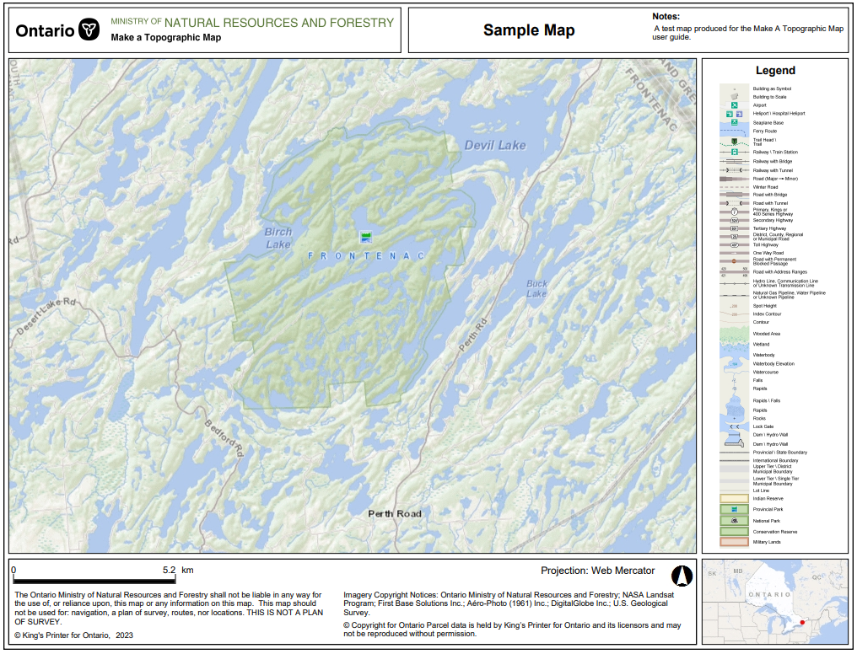

Sample map produced using the MATM print function

Version 1920.1