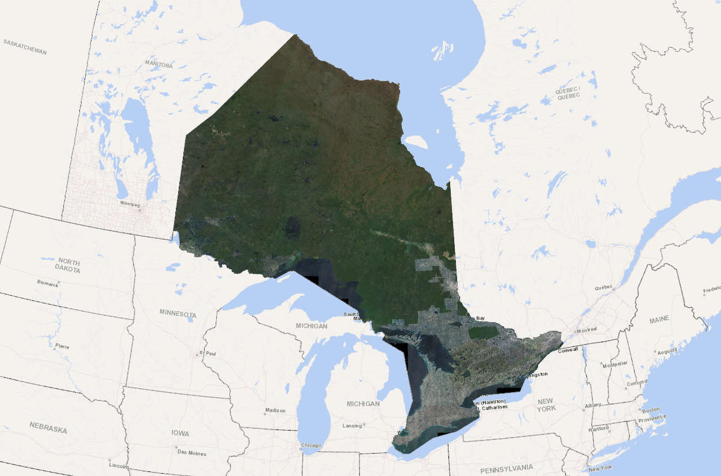

Imagery User Guide

Ministry of Natural Resources and Forestry

Land Information Ontario

#### November 2023

Ontario logo

The trillium is the official symbol of the Government of Ontario 

# Disclaimer

This technical documentation has been prepared by His Majesty the King in right of Ontario as represented by the Ministry of Natural Resources and Forestry (the “Ministry”). No warranties or representations, express or implied, statutory, or otherwise shall apply or are being made by the Ministry with respect to the documentation, its accuracy or its completeness. In no event will the Ministry be liable or responsible for any lost profits, loss of revenue or earnings, claims by third parties or for any economic, indirect, special, incidental, consequential or exemplary damage resulting from any errors, inaccuracies or omissions in this documentation; and in no event will the Ministry’s liability for any such errors, inaccuracies or omissions on any particular claim, proceeding or action, exceed the actual consideration paid by the claimant involved to the Ministry for the materials to which this instructional documentation relates. Save and except for the liability expressly provided for above, the Ministry shall have no obligation, duty, or liability whatsoever in contract, tort or otherwise, including any liability or negligence. The limitations, exclusions and disclaimers expressed above shall apply irrespective of the nature of any cause of action, demand, or action, including but not limited to breach of contract, negligence, strict liability, tort or any other legal theory, and shall survive any fundamental breach or breaches.

Cette publication spécialisée n’est disponible qu’en anglais.

# Additional Information

This document does not comply with all the applicable guidelines for accessible digital documents. Some of the information in this document is nonconvertible and may not be compatible with assistive technologies. For an alternative format please contact [imagery@ontario.ca](mailto:imagery@ontario.ca/) or call 705-772-5891.

# Table of Contents

Disclaimer 2

Additional Information 2

Table of Contents 3

List of Figures 5

List of Tables 5

Background 6

Contact 6

Imagery Acquisitions 7

Orthophotos 10

Viewing 10

Bands 11

Compression 12

Stereo 13

Frame-Capture 13

Push-broom 13

Viewing and Downloading Imagery 14

Open Imagery Web Map Services 14

Ontario Imagery Web Map Service 14

Ordering Imagery 15

Appendix A: Access Rights to LIO Imagery 16

Provincial Ministries, Agencies, Boards, and Commissions 16

First Nations 16

Imagery Purchaser 16

Open Imagery 16

Appendix B: Stereo Imagery Set up Instructions 17

Modifying SUP Files (FRI, LIO 2013-2017 Imagery) 17

Modifying ISAT Stereo Models (SWOOP2010, LIO 2018—2022 Imagery) 17

File Names 18

Appendix C: Determining the Approximate Capture Date of an Image 20

Appendix D: Citation 21

Appendix C: Glossary 22

Vertical Imagery : Aerial imagery where the photograph is taken with the camera axis pointing directly toward the ground. (Ideally captures the rooftop of a building but not the sides of the building). The unprocessed imagery from an aerial survey system would be considered vertical imagery. 22

Stereo Imagery 22

Orthorectified Imagery 22

Oblique Imagery 22

RAW Imagery 22

Panchromatic (Pan) Imagery 22

Monochromatic Imagery 23

False Colour 23

Bands 23

Bit depth 23

# List of Figures

Figure 1: High resolution orthophotography acquisition 2013 - 2017. 7

Figure 2: High resolution orthophotography acquisition 2018-2022. 8

Figure 3: High resolution orthophotography acquisition areas scheduled for 2023-2027 9

# List of Tables

Table 1: A comparison between orthophotography with no stretch (left) and a “default” stretch applied to each image (right). 10

Table 2: Examples of False Colour and True Colour imagery with different band orders. 11

Table 3: Examples of the near infrared displayed as monochrome imagery. 12

# Background

Land Information Ontario (LIO) helps public and private organizations, and individuals find, access, and share geographic data. LIO is a program area that represents the Province of Ontario through the Ministry of Natural Resources and Forestry (MNRF).

Since 2002, LIO has coordinated, managed, and distributed high-resolution, digital aerial photography (imagery) acquisitions for Ontario on behalf of sector partners. These sectors have included provincial ministries, conservation authorities, municipalities, the federal government, non-government organizations, First Nations, and private entities.

The LIO Imagery Program is scheduled to acquire imagery until 2027. The objective is to provide a predictable refresh cycle for high resolution, leaf-off (spring and fall), snow and ice-free imagery in defined acquisition blocks for southern Ontario and parts of central and northern Ontario.

Ontario’s high-resolution aerial photography acquisitions are collected through partnerships with provincial ministries and other organizations interested in receiving new imagery. Partnerships can ensure the annual predictable collection of high-resolution imagery that provides high value for all participants.

The Ontario government contributes at least 40% of the cost for every imagery acquisition. Land Information Ontario manages the acquisition, the procurement of the vendor, and coordinates the areas of interest of each participant, who together fund the remaining cost of acquisition. In this cost-sharing model, as more participants contribute to the acquisition, the cost per square kilometre for every partner drops. The minimum participant contribution is kept low at $1000 to allow smaller organizations to participate. Land Information Ontario does not profit from the partnership model.

Participating in the acquisition projects provides substantial savings compared to purchasing imagery after the acquisition is complete.

Current acquisition information, as well as methods to access and order imagery can be found at [Ontario Imagery Program | Ontario GeoHub (gov.on.ca)](https://geohub.lio.gov.on.ca/pages/ontario-imagery-program).

## Contact

For general inquires or inquire about becoming a partner contact [imagery@ontario.ca](mailto:imagery@ontario.ca).

To order imagery, contact Imagery Orders at [imageryorders@ontario.ca](mailto:imageryorders@ontario.ca).

# Imagery Acquisitions

The first imagery acquisition cycle was captured over 5 years between 2013 to 2017. It covered approximately 205,000 km2 of the province.

The orthophotography was captured using a line based ADS80 Leica digital camera. The delivered imagery has a pixel resolution of 20 cm and is accurate to 50 cm on the ground at 90% confidence level. See Figure 1 for the acquisition coverage.

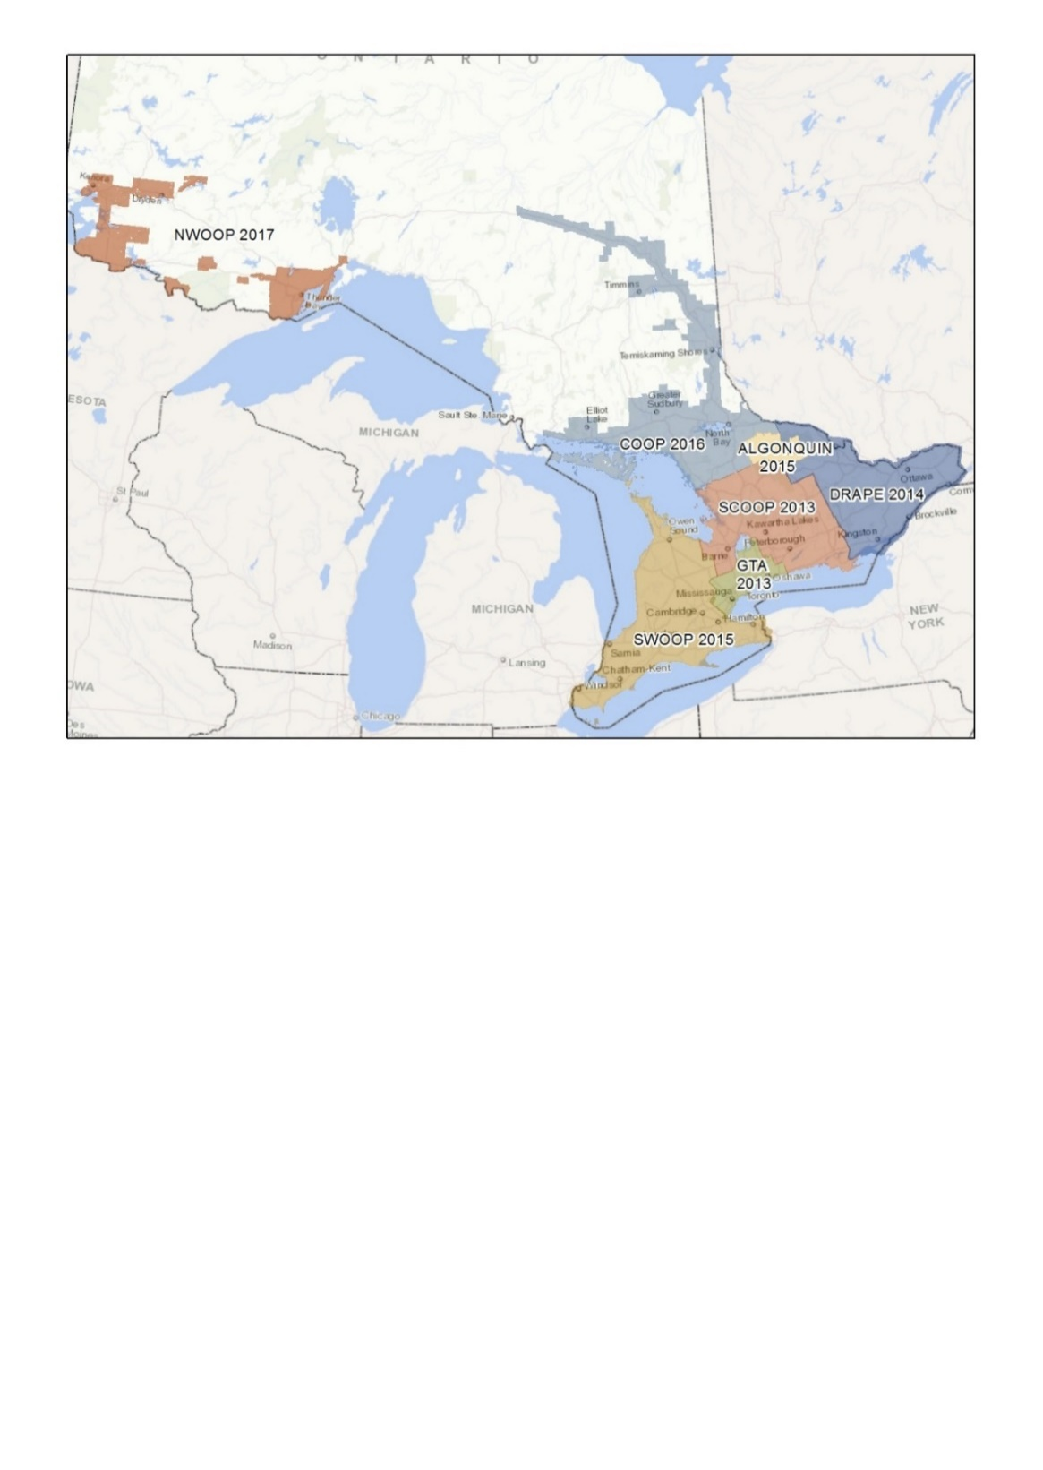

Figure 1: High resolution orthophotography acquisition 2013 - 2017.

The second imagery acquisition cycle was captured over 5 years between 2018 to 2022. It covered approximately 214,000 km2 of the province.

The orthophotography was captured using a Vexcel Ultracam digital camera. The southern acquisition was captured between 2018 to 2020, has a pixel resolution of 16 cm and is accurate to 45 cm on the ground at the 95% confidence level. The northern acquisition captured in 2021 and 2022, has a pixel resolution of 20 cm and accurate to 60 cm on the ground at the 95% confidence level.

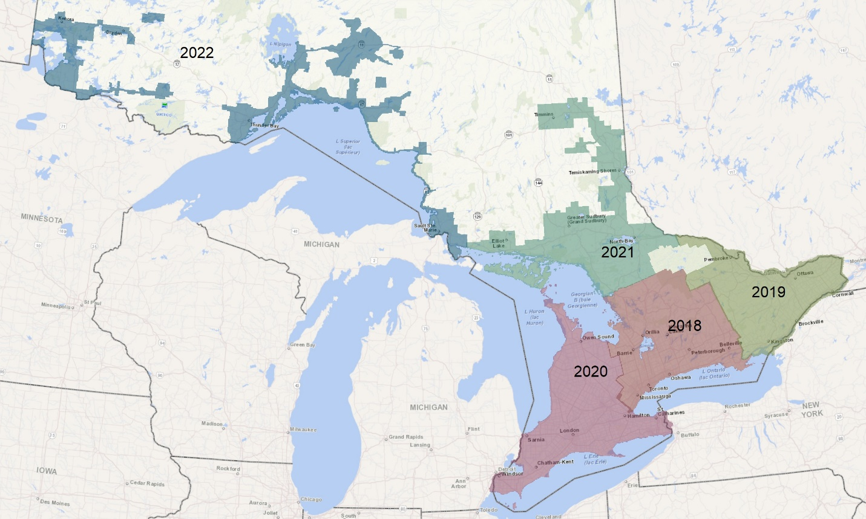

Figure 2: High resolution orthophotography acquisition 2018-2022.

The specifications for the third five-year acquisition cycle scheduled for 2023 to 2027 mirror the second acquisition cycle. The southern acquisitions scheduled for 2023 to 2025 will have a resolution of 16 cm, accurate to 45 cm 95% of the time. The northern acquisitions scheduled for 2026 to 2027 will have a resolution of 20 cm, accurate to 60 cm 95% of the time. See Figure 3 for acquisition areas.

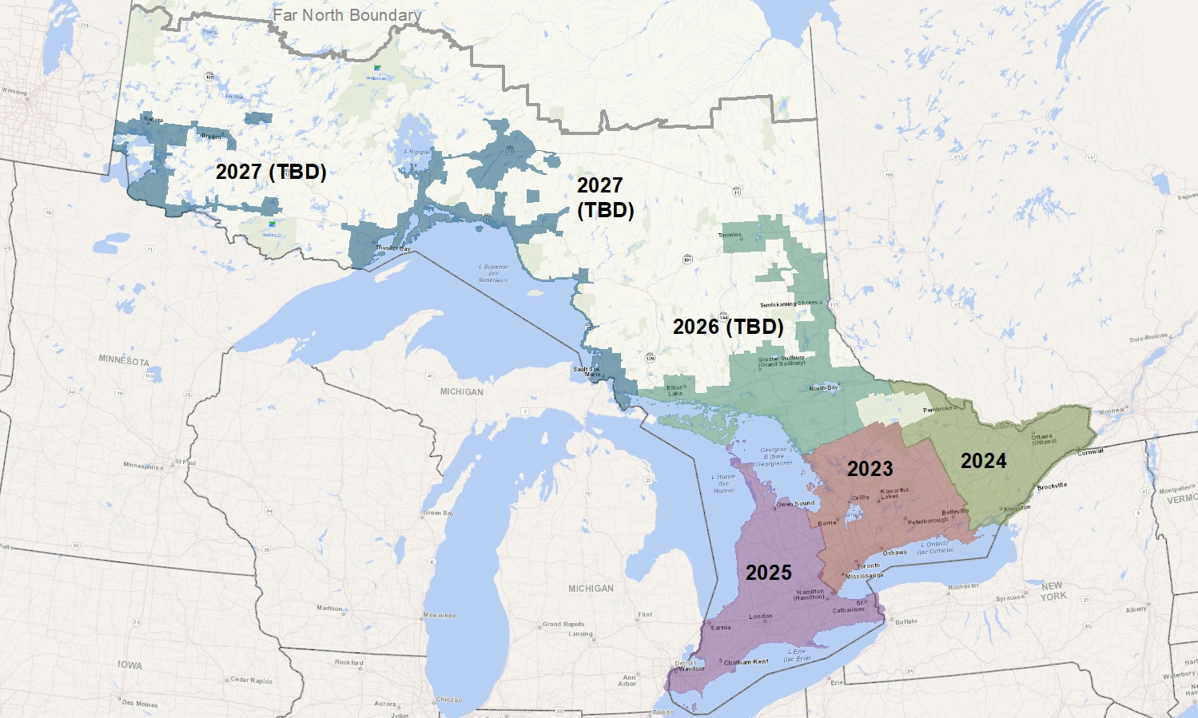

Figure 3: High resolution orthophotography acquisition areas scheduled for 2023-2027

# Orthophotos

Orthophotos are captured by an aircraft because of its ability to obtain high resolution products over a large area. The goal is to acquire during the spring under optimal conditions for imagery collection; cloud free, snow free, ice free, smoke free, and leaf off conditions.

The orthorectified tiles (orthophotos) are projected into 1 km squared tiles, in the Universal Transverse Mercator (UTM) projection. The orthorectification process geometrically corrects the image, removing the effects of camera tilt, and elevation, so that the scale throughout the photo is uniform, which accurately positions the photo in the correct location. The photo can be directly laid on a map (at the same scale). Their primary intended use is within GIS software or web mapping applications and can be used for a wide range of purposes.

## Viewing

Each acquisition is produced with the intention of viewing the entire product and should have a similar tone or appearance from tile to tile. To preserve as much as possible the original values in each capture, there are no tonal adjustments made between acquisitions. Viewing acquisitions side by side could have an abrupt tonal difference between them.

To properly view the orthophotography, it is important to ensure that any default stretch settings within the software are set to none. See Table 1.

|  |  |
| --- | --- |
| Correct Stretch set to “None” | “Default” stretch applied to each image. |
| Image one of two comparatively showing the results of stretch settings set to "None". | Image two of two comparatively showing the results of stretch settings set to "Default". |

Table 1: A comparison between orthophotography with no stretch (left) and a “default” stretch applied to each image (right).

## Bands

All colour display technologies use three channels of light RGB (red, green, blue) to render the image on screen. Reordering the bands and adding a 4th band, near-infrared (NIR) wavelength can support image analysis.

The default band order, and near infrared band identifies the name of the product (i.e., RGB = 3 bands True Colour, NRGB = 4 bands False Colour, RGBN 4 bands True Colour). A true colour image aligns with these channels to render objects in the image in natural colours.

|  |  |  |  |
| --- | --- | --- | --- |
|  | NRGB Original (False Colour) |  | NRGB with Bands Reordered |
| R=1(N) G=2(R) B=3(G) | Air photo image showing the NRGB False colour band order. | R=2(R) G=3(G) B=4(B) | Air photo image showing the NRGB with bands reordered. |
|  | RGBN Original (True Colour) |  | RGBN with Bands Reordered |
| R=1(R) G=2(G) B=3(B) | Air photo image showing the RGBN True colour band order. | R=4(N) G=1(R) B=2(G) | Air photo image showing the RGBN with bands re-ordered. |

Table 2: Examples of False Colour and True Colour imagery with different band orders.

To display an image containing near infrared data, 3 of the 4 bands containing data must be chosen to fill those channels. The most common rendering discards the blue data, renders the green data on the blue channel, the red data on the green channel, and the near infrared data on the red channel. While this renders a colour image, the colours are not natural and are referred to as false colour (monochrome image). See Table 3.

|  |  |  |  |  |
| --- | --- | --- | --- | --- |
|  | NRGB Original Near Infrared Monochrome |  |  | RGBN Original Near Infrared Monochrome |
| Band 1 | Air photo image showing the near infrared displayed as monochrome. |  | Band 4 | Air photo image showing the RGBN Infrared monochrome. |

Table 3: Examples of the near infrared displayed as monochrome imagery.

## Compression

A lossy compressed version of the imagery can be provided. This reduces the size of the orthophoto tile. The compressed files will be generated using the lossy Tiled TIFF format at a 20:1 compression ratio.

Compression does change the values within the imagery. If image analysis is required using the imagery, a lossless or uncompressed version may be appropriate.

## Stereo

Associated digital vertical imagery that has not been orthorectified is intended for use with specialized 3D stereo viewing software.

Two major technologies have been used to capture stereo images: the frame imaging approach; and the linear array technology or push broom approach.

### Frame-Capture

Frame captured images are captured in quick succession with a designated overlap between photos (forward overlap). The image extents (ground cover) vary among collections and within collections due to the model of camera used to acquire the image. The flight line of the plane also creates a lateral flight line overlap which can be used to patchwork the imagery together to form a seamless dataset using ground control points’s and frame tie points. i.e., SCOOP2018 using a Vexcel UltraCam Eagle):

### Push-broom

Push-broom capture relies on digital sensors that continuously scan the ground and create strips of imagery. There is overlap in the capture with a forward view, nadir view and backward view to give 3x full coverage. Lateral overlap is generally reduced over frame-based capture. Seamlines are greatly reduced when compared to frame-based capture. i.e., SWOOP 2015 was captured using a Leica ADS80.

For detailed information on how to set up Stereo Imagery, refer to Appendix B

# Viewing and Downloading Imagery

[Ontario GeoHub (gov.on.ca)](https://geohub.lio.gov.on.ca/) contains metadata records, outlining detailed information of all LIO imagery collections. If an imagery collection name is known, you can directly search for the data set within the Ontario Geohub to bring up a page with all available information and links regarding that data set.

To ensure tiles are suitable, representative samples of imagery are available for download from the main [Ontario Imagery Program | Ontario GeoHub (gov.on.ca)](https://geohub.lio.gov.on.ca/pages/ontario-imagery-program) page. This page also contains up to date information such as current acquisition information, as well as all means to access and order LIO imagery.

LIO orthophotography acquired more than six years ago is now available openly and can be found through the Ontario Imagery Program page. Most open imagery datasets are available via hosted web map services (WMS) for easy viewing or loading into GIS software.

## Ontario Imagery Web Map Service

The Ontario Imagery Web Map Service (OIWMS) contains the best available imagery for an area. This service can be viewed publicly through Land Information Ontario applications such as [Make A Topographic Map (gov.on.ca)](https://www.lioapplications.lrc.gov.on.ca/MakeATopographicMap/index.html?viewer=Make_A_Topographic_Map.MATM). The service is updated annually, within four months of receiving a new imagery.

# Ordering Imagery

Use the [Imagery Order Form](https://www.publicdocs.mnr.gov.on.ca/mirb/Ontario_Imagery_Order_Form.docx) for ordering imagery or when seeking specific product information for both restricted and open data products. Visit the [Ontario Imagery GeoHub (gov.on.ca)](https://geohub.lio.gov.on.ca/pages/ontario-imagery-program) page to navigate to the most comprehensive product information.

Fill out the imagery order form and provide a list of orthophotos you are requesting to [imageryorders@ontario.ca](mailto:imageryorders@ontario.ca). Each acquisition will have one or more products available with a corresponding index to help create a list. An orthophoto tile/stereo list can be created by viewing the index (.shp) in GIS software. Select an area of interest, within the index and export the selection to a shapefile or create a dbase (.dbf) file. Please ensure full tile names or file names are used when providing a list.

Multiple lists can be submitted with one order form. Sizes per tile or stereo line/frame are provided on the imagery order form, in the metadata records and as a field within the product index.

Due to the size of imagery, downloading of your order may not be possible. A request for imagery is required and depending on the size of the order, the tiles may be posted on an FTP for download or can be mailed on media. For more information and dissemination options, please see the [Imagery Order Form](https://www.sdc.gov.on.ca/sites/MNRF-PublicDocs/EN/CMID/Ontario_Imagery_Order_Form.docx) Delivery Information – Table 3 (Table 3)

# Appendix A: Access Rights to LIO Imagery

## Provincial Ministries, Agencies, Boards, and Commissions

Ontario ministries (and their associated non-profit agencies, boards, or commissions) that contribute to the LIO Imagery program on an annual basis can obtain any imagery holding without further charge.

## First Nations

For imagery where the intellectual property is owned by the Crown, First Nations can obtain imagery covering their reserve free of charge.

## Imagery Purchaser

Imagery that is less than six years old must be purchased by those that were not a partner in the acquisition, are not a provincial ministry, agency board or commission that contributes to the LIO Imagery Program or are not part of a First Nation. Please see Accessing LIO Imagery to get started with purchasing imagery.

## Open Imagery

Orthophotography where the intellectual property is owned by the Crown and is greater than six years old from the time of collection is classified as open data and can be accessed via the methods outlined in this document under Accessing LIO Imagery.

# Appendix B: Stereo Imagery Set up Instructions

Stereo Imagery can be viewed in 2D but to see it as intended in 3D, the hardware required is listed below, you will need one of the three viewing options and then a software suite to visualize the imagery.

1. Red/Cyan Anaglyph 3D glasses
2. Stereoscopic 2 panel display w/ glasses
3. Nvidia 3D Vision Solution
   * 3D Vision Capable Monitor
   * Appropriate viewing Glasses for your chosen monitor
   * Supported Graphics Card with 3D software installed
     + Support for 3D vision from Nvidia ended in April of 2019 with Driver 418 as the final driver with support for the technology.

* ArcGIS 10.3 and above or ArcGIS Pro 2.1 and above
* An extension or license for visualizing or analyzing Stereo Data
  + Image Analyst (ESRI) for ArcGIS Pro or,
  + Stereo Analyst (Hexagon Geospatial) for ArcGIS10.3+

## Modifying SUP Files (FRI, LIO 2013-2017 Imagery)

* SOCET SET utilizes the .sup files (BAE Systems)
* Native support from Arcmap was ended as of 10.2
* .sup files can be opened in a text editor and file paths can be modified to match the user’s data location

## Modifying ISAT Stereo Models (SWOOP2010, LIO 2018—2022 Imagery)

* ISAT is a multifile format, text files with fixed names (no extensions) are contained in a folder, the folder name is the name of the stereo model.
* Below is a breakdown of the file structure:

\FOLDERNAME (the name that will appear in Stereo Analyst when importing)

\photo (photo measurements, photo parameters (paths))

\model (orientation data for stereo pairs)

\project (parameters for AT project)

\camera (camera details)

\control (control point data)

\CSF (coordinate system file)

* The photo file is important as this holds the file paths to the imagery.
* When using Stereo Analyst and importing a project the user has the option of temporarily repointing the file paths to a user defined place to view the imagery. This will not change the referenced path in the photo file though.
* The photo file should be edited to match the user’s data path to view the photos. These references are located down in the lower portion of the photo file for each photo in that model.
* The number of photos per model can approach 1200 images, these have been standardized to a common path.
* An example of an image path name is:

x:\SCOOP2018-UTM18-Stereo-RGBN-16bit-12cmTIFF\ SCOOP2018_3_123_38138_MY21.tif

## File Names

Components of name:

Project Name-Projection-Imagery Type-Bands-Bit Depth-Cellsize.Filetype

**Project Name** - The name of the project that produced the imagery combined with the year the project was associated with (generally but not always the year the imagery was captured)

**Projection** - A simple description of the projection that has been applied to the imagery through the orthorectification process. Where indicated in a stereo product it is the projection utilized when stereo models were created for the imagery (projection of the ortho imagery derived from the stereo products).

**Imagery Type** - Indicates the type of the imagery product. *Stereo* will be used to describe stereo pairs and *Ortho* to describe orthorectified imagery. Both types are the most common in the LIO library. Other possibilities include raw, oblique, and vertical.

**Bands** - Indicates what bands are present in the product and what order they are present in. NRGB would indicate that 4 bands are present being Near Infrared, Red, Green and Blue, in that order.

**Bit Depth** - Refers to the range of values used to describe the colour information in each band of imagery. Generally, these will be 8Bit (256 possible values in each band), or 16bit (65,536 possible values in each band). Normally source data (stereo) is retained in 16bit if possible. The greater range of values allows for more manipulation of the imagery to be performed without visible signs of the manipulation (stretches, geometric transformations). It may also be possible in rare cases to extract greater detail from shadows or highlights than is possible with 8Bit imagery.

**Cellsize** - Indicates the resolution of the imagery describing the size of each pixel in ground units; the same units as the projection for ortho imagery. For Stereo and other vertical imagery this value is more accurately referred to as the Ground Sample Distance or the target sample size to be captured at each pixel.

**Filetype** - Indicates the format in which the imagery is stored. LIO typically uses the TIFF format for a lossless format, and in the case of Compressed(C) imagery, LIO uses TIFF with tiled JPEG compression (or Tiled Tiff). Tiled Tiff format may not be readable by software designed for photography and is intended for use in GIS software. Older imagery may utilize other compression. Similarly, stereo formats may indicate SOCET SET which requires specialized software.

# Appendix C: Determining the Approximate Capture Date of an Image

To determine the approximate capture date of an orthophotograph, obtain the stereo photograph index provided in [Ontario GeoHub (gov.on.ca)](https://geohub.lio.gov.on.ca/) using GIS software. Within the attribute table of the stereo index, the capture date is recorded in a field entitled “DataAcquir”.

Overlay the orthophotography with the stereo index and use the “DataAcquir” field in the stereo index attribute table to determine the approximate date of capture.

Note that an orthophotograph can be made up of many images from the stereo index. It is also possible that an orthophotograph may have a date range rather than a single capture date.

# Appendix D: Citation

Cite the appropriate acquisition project year of collection in the following format:

Source: Data provided by the Ontario Ministry of Natural Resources and Forestry © Copyright: <Project Year> King's Printer of Ontario All Rights Reserved.

Example: Data provided by the Ontario Ministry of Natural Resources and Forestry © Copyright: 2022 King's Printer of Ontario All Rights Reserved.

Not all imagery obtained from LIO can be cited using this method. This format is only for imagery where the intellectual property belongs to the MNRF.

# Appendix C: Glossary

### Vertical Imagery : Aerial imagery where the photograph is taken with the camera axis pointing directly toward the ground. (Ideally captures the rooftop of a building but not the sides of the building). The unprocessed imagery from an aerial survey system would be considered vertical imagery.

### Stereo Imagery

Overlapping pairs or strips of vertical imagery that allow stereo viewing of imagery. Can be used for mapping features in all three dimensions and generating elevation models of the ground.

### Orthorectified Imagery

Imagery that has been geometrically corrected and projected for use in mapping and GIS applications. It is a photographic map. Since anorthophoto has a uniform scale, it is possible to measure directly on it like other maps. An orthophotomay serve as a base map onto which another map information can be overlaid.

### Oblique Imagery

Aerial imagery where the photograph is taken at an inclination to the ground (used to capture the sides of a building, or other terrestrial feature).

### RAW Imagery

Unprocessed data captured by the sensor of an aerial digital camera system. The resulting format usually requires proprietary software from the camera manufacturer to process into a format consumable by other software.

### Panchromatic (Pan) Imagery

Imagery in which the full spectrum of visible light has been captured in a single band. It is often referred to as Black and White photography.

### Monochromatic Imagery

Imagery that captures only a defined range (or color) from the electromagnetic spectrum. Most often used for near infrared imagery or thermal imaging. It is also displayed as black and white images.

### False Colour

Refers to the technique of rendering an image in colour from data that is normally not seen within the visible light spectrum. Used for rendering data from multispectral and hyperspectral imaging platforms, most often employed for near infrared data within the LIO catalogue.

### Bands

“Bands” describes how the visible and near visible electromagnetic spectrum (light) has been captured within imagery. The bands represent specific portions of this spectrum.

When imagery contains multiple bands, it is referred to as multispectral imagery. There are typically 4 multispectral bands that are common in GIS imagery (although there can be more in satellite imagery). They are Red(R), Green(G), Blue(B) and Near Infrared(N\I). Descriptors contain only the letters often accompany imagery data either in metadata or product descriptions. Common examples include:

“NRGB” – 4 Band false color

“RGB” – 3 Band true colour

“RGBI(or N)” = 4 Band true color (the infrared data is in the 4th position so the image opens with a natural appearance).

### Bit depth

A reference to how much detail within each band is captured within the imagery, most often being 8bit or 16bit. These numbers represent the number of bits used to record the data for each band within each pixel and therefore the number of different values that can be contained within the pixel.