Sensitive Data Location Standards

To protect species and ecosystems, you must use location data for provincially tracked species, plant communities, and wildlife concentration areas responsibly.
If you wish to include location information for provincially tracked species, plant communities, or wildlife concentration areas in products such as reports, maps, charts, or presentations that you intend to share with unlicensed users, you must generalize all location information to the level the Ministry of Natural Resources and Forestry (MNRF) makes available to general users. For most species, this means displaying data at a 1-km grid resolution (see Figure 1).
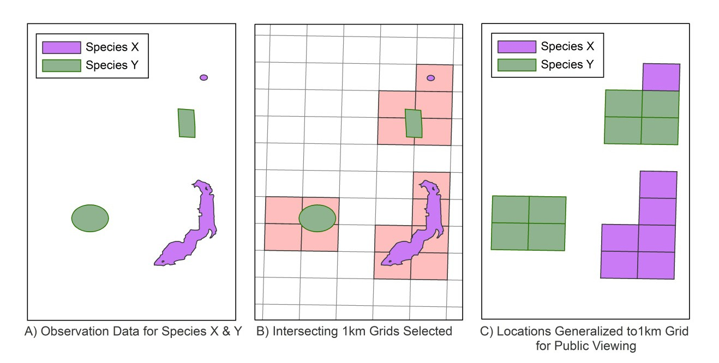
Figure 1. MNRF minimum standard generalization
Generalizing location information to a 1-km grid resolution obscures actual locations enough to secure confidential values. This level of detail is acceptable for activities such as landscape-level planning and site screening.

Restricted elements
Restricted elements are species, plant communities, or wildlife concentration areas that are at high risk of exploitation, are sensitive to disturbances, and/or could be harmed if data are not appropriately protected. In species datasets restricted elements have a value of “Y” in the RESTRICTED_SPECIES field. In wildlife concentration area datasets restricted elements have a value of “Y” in the DATA_RESTRICTION_IND field.
If you need to share data for any restricted elements with unlicensed users, contact the Natural Heritage Information Centre for guidance.
To share any restricted data, you will need written approval from the MNRF.

Sharing detailed data (for example, detailed maps or lists of locations) with individuals you feel have a legitimate need-to-know
If your agency has a Sensitive Data Use Licence Agreement with the MNRF, then employees, representatives, or agents of your agency who have a legitimate need-to-know can access detailed data. The data can only be used for the project or purposes identified in the licence. Any employees, representatives, or agents who will be viewing or working with the data must complete sensitive data training prior to accessing the data.
If the person you wish to share data with is not an employee, representative, or agent of your agency, then you cannot share detailed data with them. It is up to the MNRF to determine who has a legitimate need for detailed information.
Questions? Contact the Natural Heritage Information Centre at NHICrequests@ontario.ca or 705-755-2159.
Some of the information in this document may not be compatible with assistive technologies. If you need any of the information in an alternate format, please contact NHICrequests@ontario.ca.

